4.

Create the snapshots like in the picture below using one of the virtual machines created in the previous exercises. Before each snapshot, you must change something in the operating system. This tool is normally used when performing a critical action or installing software. But, in this case, you can do something so easy as creating a new file to study the different states.

To do this action we must to go to our virtualbox and select the virtual machine that we want to create a snapshot.

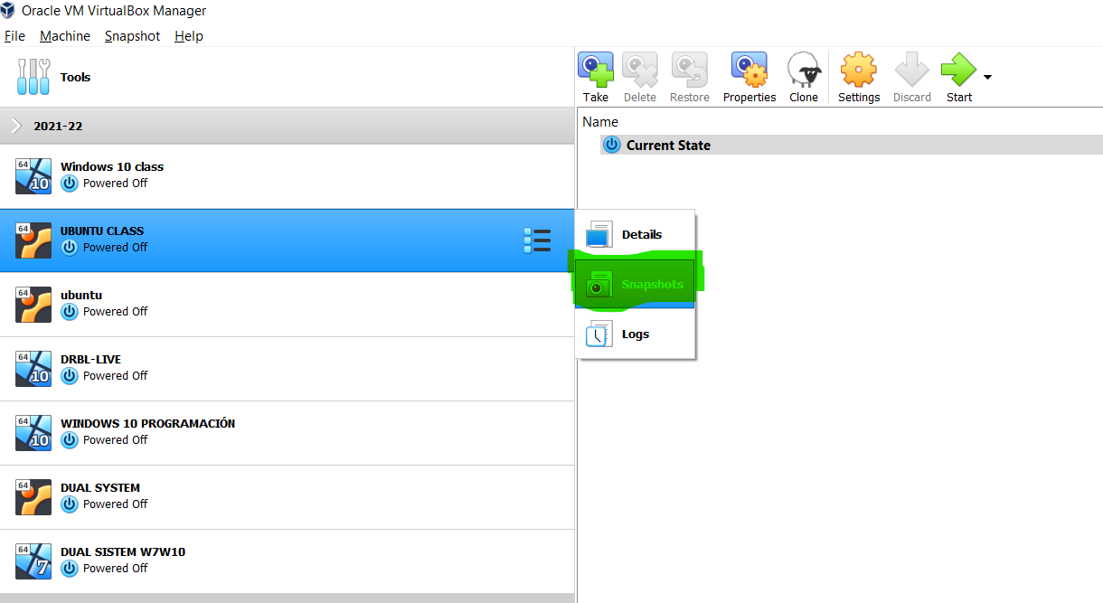

As it is showed in the picture above, we have Access to a new menu, from there we can create our snapshots.

We click => take snapshot, in order to create a snapshot of our current state

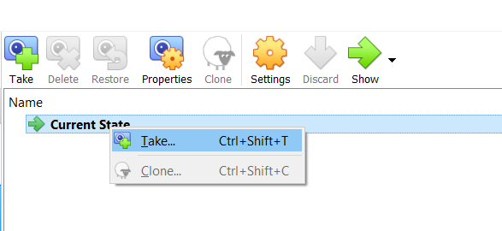

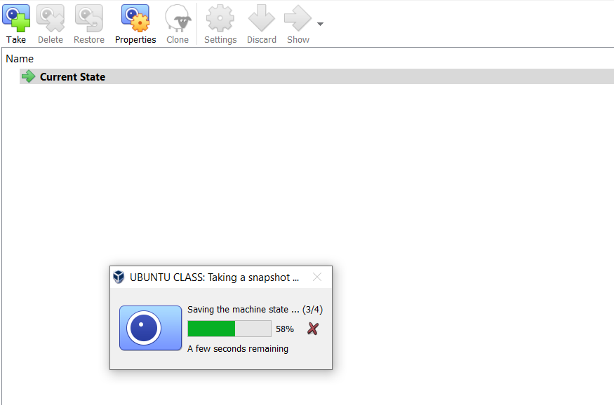We can see how it was create a snapshot

that we named initial state, that

represent the state before any change.

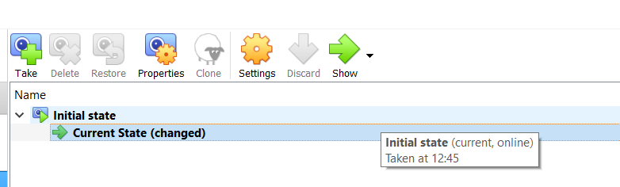

Then we create a new file in order to see the diference with the diferentes snapshots that we will create.

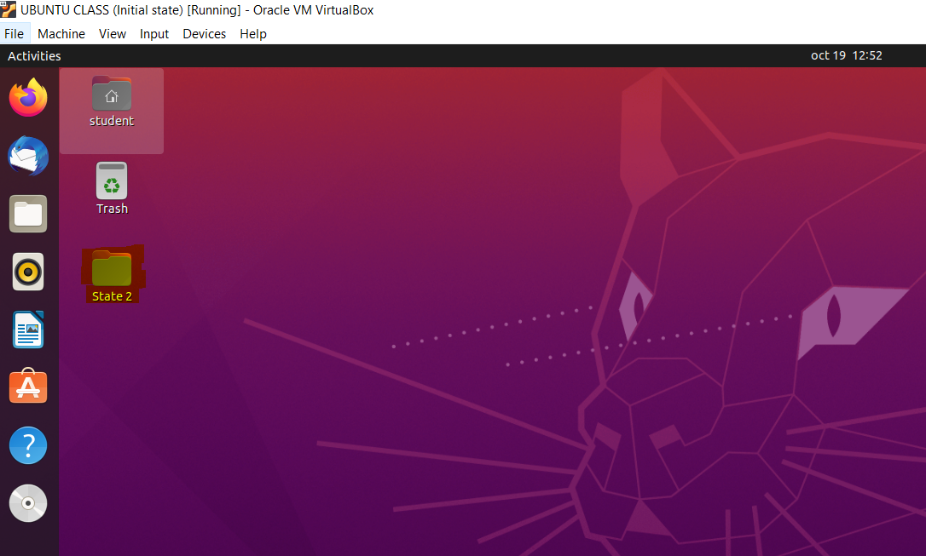

Now we create a new snapshot.

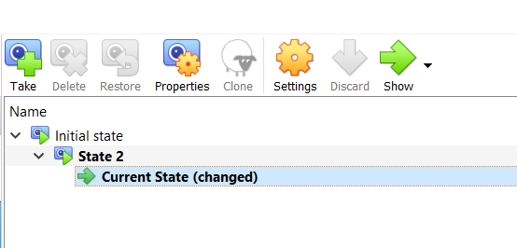

We will do this till achive the next stapshots, and in each state we will create a new folder to see the diference between each snapshot.

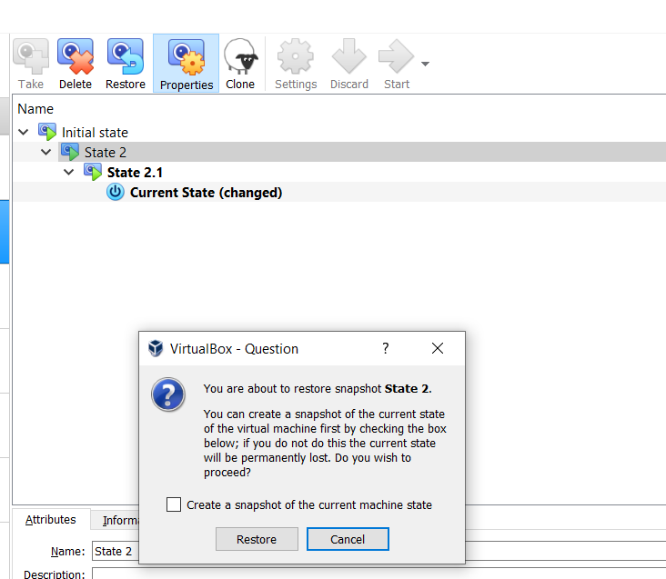

In this point we have to restore the state to in order to create a new snapshot named State 2.2, in the same level like State 2.1.

Now we have all the snapshots

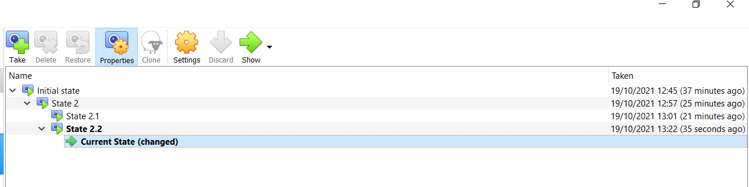

Then, complete the following actions in order:

• Restore State 2

When we restore the Stete 2 we came back to the state when we have just one folder.

• Delete State 2.1 and explain what happens

When this happens we can observe that the state is the same like state 2.

• Restore State 2.2

When we restore this state we can see how our folder state 2.2 appear again.

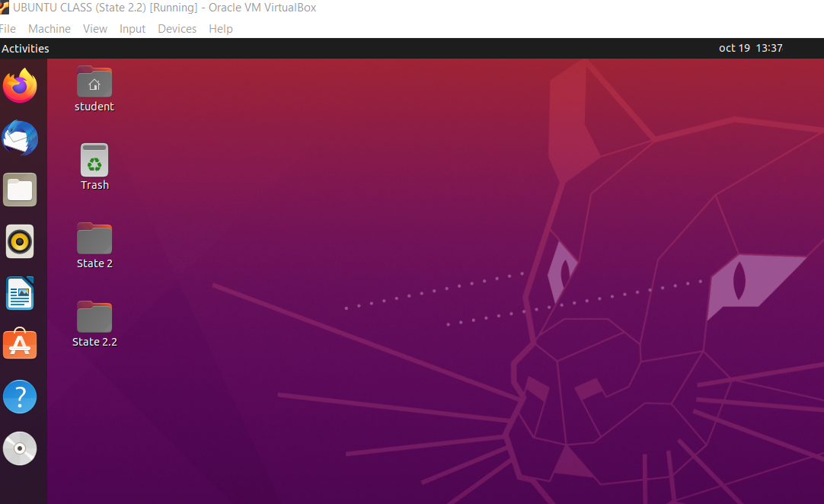

• Delete State 2.2 and explain what happen

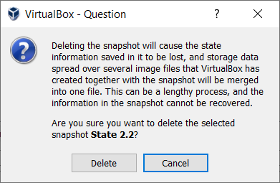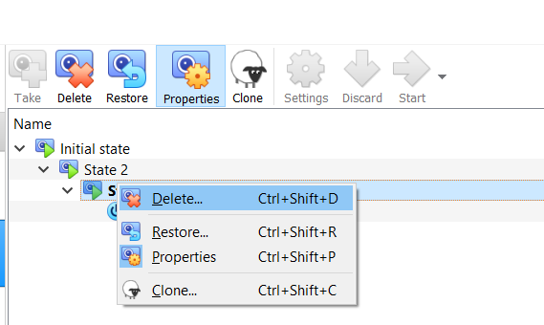

Even we deleted the state 2.2 we will oberve that the file 2.2 still are there, that is because the state 2.2 and state 2 are in the same Bruch and depend on each other.